Urdu MEachine Reading Comprehension

Software requirements specification

 | - Department of Computer Science  Forman Christian College (A Chartered University)

Title Page
- Project Title: Urdu Machine Reading Comprehension
- Project Adviser Name: Ali Faheem
- Project Secondary Adviser Name: Akheem Yousaf
- Project Team: Salman Anwar (22-10391), Zarek Asif (22-10582) & Eraj Khurshid (22-10457)
- Submission Date
- Signatures of Project Adviser and Project Secondary Adviser
- Signatures of Team Members

Table of Contents
Table of Contents iii
Revision History iv
1. Introduction 1
1.1 Review of Related Literature 1
1.2 Problem Statement 1
1.3 Proposed Solution 1
1.4 Problem Scope 1
1.5 Challenges 1
1.6 Knowledge Areas Required 1
1.7 Completeness Criteria 1
1.8 Research Outcomes/Nature of End Product 1
1.9 Learning Outcomes 1
1.10 Document Conventions 1
2. Background Study and Literature Survey 2
3. Overall Description 2
3.1 Proposed Solution 2
3.2 User Classes and Characteristics (if applicable) 2
3.3 Operating Environment 2
3.4 Design and Implementation Constraints 2
3.5 Assumptions and Dependencies 2
4. Functional Requirements 3
4.1 Requirement 1 OR Use-Case 1 (if requirements are modeled as use cases) 3
4.2 Requirement 2 OR Use-Case 2 (and so on) 3
4.3 Proposed Workflow 4
4.4 Analysis and Modeling of Requirements 4
5. Nonfunctional Requirements 4
5.1 Target Performance 4
5.2 Safety Requirements (if applicable) 4
5.3 Security Requirements (if applicable) 4
5.4 Additional Software Quality Attributes 4
6. Other Requirements 4
7. Initial Results 5
8. Revised Project Plan 5
9. References 5
Appendix A: Glossary 6
Appendix B: IV & V Report 7
(Independent verification & validation) 7

Revision History
Name | Date | Reason For Changes | Version

Introduction

Review of Related Literature
Development of an Urdu Question Answering Training Data for Machine Reading Comprehension. Squad datasets use two methods which are machine translator and human based survey. Ng, Teo, and Kwan (2000) have developed a machine learning based MRC system and introduced some of features to be extracted from a context sentence like “the number of matching words/verb-types between the question and the sentence”, “the number of matching words/verb-types between the question and the previous/next sentence”, “co-reference information”, and binary features like “sentence-contain-person”, “sentence-contain-time”, “sentence-contain-location”, “sentence-is-title” and so on
Two main deep learning architectures used by MRC researchers are the Recurrent Neural Network (RNN) and Convolutional Neural Network (CNN). On the other side we have Transformer Model which is a multi-lingual pre-trained model and used to train machine for 100 languages which include Urdu as well. After implementation there were many queries and very less accuracy in the translation, which was done through machine. on the other side, machine translation took a lot less time but was less accurate

Problem Statement
Machine Reading Comprehension (MRC), or the capacity to peruse and comprehend unstructured text and afterward answer inquiries concerning it stays a difficult errand for computers. Machine Reading Comprehension (MRC), which requires a machine to respond to questions given the pertinent reports, is a significant method for testing machines capacity to comprehend human language.
It is an innovation that utilizes calculations to cause computers to comprehend the semantics of texts and answer related inquiries. Lately, with the fast advancement of machine learning, particularly deep learning, the examination of machine reading comprehension has gained incredible headway, and it has arisen in reasonable applications.
Machine reading comprehension is a difficult errand and interesting issue in regular language handling.
Low-resource Machine Reading Comprehension (MRC) has made great progress in recent years, with models achieving outstanding results on a variety of language datasets.

Proposed Solution
The overall goal of the project is to create an Urdu machine reading comprehension system that will answer questions automatically after reading the article. Others who used English language datasets and had trouble answering questions correctly after translating them will find our approach superior. To improve the accuracy of our answers, we'll use an Urdu dataset.

Problem Scope
For the users, this software system will be a Web Application. It will be meant to increase the user's productivity by giving him or her tools to help automate the responses to the user's comprehension questions, which would otherwise have to be done manually. The system will meet all needs while being simple to comprehend and use by maximizing the user's work productivity and production.
More specifically, this system is designed to allow a user to enter a specific paragraph or article, then ask questions about that paragraph or article, and the machine would produce and provide the user with the correct answer based on the text. A relational database with a list of distinct Machine Learning responses and queries is also included in the system.

Challenges
The first and foremost challenge will be the translation of databases into Urdu language. To identify which technique (Machine Learning, Rule Based or Transformation Based Model) would be suitable for Machine Reading Comprehension.

Knowledge Areas Required
Deep Learning, Implications of techniques like Rule Based, Machine learning and Transformation Based Model. Natural Language Processing.

Completeness Criteria
It’s a complete checklist which we will check at the end of the project which will contain all the features which w are going to implement in the application

Research Outcomes/Nature of End Product
The outcomes will include dataset and the most appropriate algorithms to deals with the classification, accuracy and efficiently that can be further taken up into building a prototype model that can be used on the internet.

Learning Outcomes
We will be able to use different machine learning, rule-based algorithms to create a important software.

Document Conventions
The document is formatted using APA rules where the fonts are of 12 size and style is times new roman.

Background Study and Literature Survey
Machine Reading Comprehension is a cutting-edge technology in Natural Language Processing (NLP). It’s the ability to read and understand unstructured text. It is one of the key problems in Natural Language processing, in which the software has to read and comprehend the provided context, and then it produced the precise answers based on the questions. It is a developing field of exploration because of its potential in different venture applications. However, not a single model has been custom-built for the Urdu language. MRC is a significant method for testing machines capacity to comprehend human language. Urdu Machine reading comprehension is a difficult errand and interesting issue in natural language handling. Natural language processing (NLP) alludes to the part of software engineering and more explicitly, the portion through which human being communicate or AI-worried about empowering computers to get text and verbally state words in the way individuals can. NLP joins computational etymology rule-based displaying of human language-with measurable, AI, and profound learning models. In the recent research paper, its present a thorough review on various parts of machine understanding comprehension frameworks, including their methodologies, structures, and exploration curiosities. Lately, low-asset Machine Reading Comprehension (MRC) has gained huge headway, with models getting wonderful execution on different language datasets. Since there is not much work that was done in this regard hence, we do not really have detail to cover except the possible algorithms used generally in NLP that are fruitful in providing us decent results. A project was done by a team from School of Mathematics & Computer Science Institute of Business Administration, Karachi, Pakistan on Urdu Question Answering Dataset (UQuAD1.0). This project investigates the semi-automated making of the Urdu Question Answering Dataset (UQuAD1.0) by using joining SQuAD with man-made tests from online sources. UQuAD1.0 is a huge scope Urdu dataset expected for extractive machine perusing appreciation errands comprising of 49k question Answers sets being referred to, section, and answer design. In UQuAD1.0, 45000 sets of Question Answer had been created by machine interpretation of the first SQuAD1.0 and around 4000 sets through publicly supporting. In this review, they utilized two sorts of MRC models: rule-based sliding window baseline and advanced Transformer-based models. Notwithstanding, they have found that the last option beats the others; in this way, they have chosen to focus exclusively on Transformer-based designs. Utilizing XLMRoBERTa and multi-lingual BERT, they obtain a F1 score of 0.66 and 0.63, separately. The next question is: How will our work be any different from them? To answer this, we will be using CNN daily dataset with SQuAD dataset to make our software working fast and get more precise answers to the questions. And with that we are also implementing multiple rule-based technique not just one technique which they have use in their dataset. We will also be working with Machine-learning model. We will be using addition models and addition datasets to make our software working more precisely and efficient than before.

Overall Description

Proposed Solution

Evaluation
Urdu Dataset
English Dataset
Translation Process

Processing

Rule Base Model
Machine Learning Model

Sliding Window
Supervised Models
General to Specific

Exact Match
F1 Score

User Classes and Characteristics (if applicable)
Login: A home page will be displayed in which the user and the admin will be asked to provide their login and password. If the user or admin is registered, he/she will directly enter the login details and will be able to access the account. Otherwise, he/she will create an account.

Enter Article/ Text/ Image: The user will be provided with the space to enter the article/ text or
image which will contain a max of 500 words.

Enter the Questions: The relevant questions from the given text will be entered by the user.

Get Answer: A feature will be available at the end of the page to process the questions after those answers will be displayed.
Admins will be able to access the question answers and text of all the members

Operating Environment
Minimum system requirements include 8gb of ram, more than 250gb of storage (SSD) and windows 10.

Design and Implementation Constraints
The first Constraint will be that we need a huge dataset for the effective learning of the machine. After that conversion of the dataset into Urdu language will be a big task. Identifying the correct technique(s) to apply (such as Rule Based and Machine Learning based Technique) into the program so that the biasness and efficiency of the program will be ensured.

Assumptions and Dependencies
The kind of software being used to develop the datasets will greatly affect the speed of progress. To ensure that software works smooth it must go through a lot of trial to ensure minimal bugs. We are assuming that our text translation from English to Urdu will be accurate by using Squad dataset and CNN daily dataset. Furthermore, we are assuming to use different techniques of rule-based model in our software so that our software will give a precise answer to the question. If there will be any bug in the techniques or datasets which we are using than the software will not work properly and will not give the accurate answer.

Functional Requirements
Functional requirements are the Basic functions needed to perform the Machine Reading Comprehension. Functional requirements are presented in the form of use cases. These use cases are the basic components of our system.

Use Case Diagram:

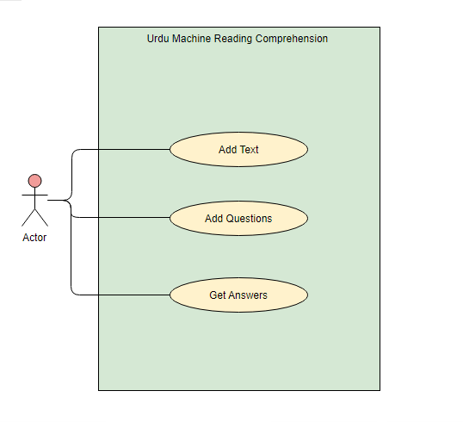

Add Text
Identifier |  | Add Text
Purpose |  | Purpose is to provide the Content to the system
Priority |  | High
Pre-conditions |  | User must have opened the system
Post-conditions |  | Text uploaded Successfully Message
Typical Course of Action
S# | Actor Action |  | System Response
1 | First user will Click on Add Text button. |  | Text Here Box will be highlighted.
2 | User will type text or Copy the Content from anywhere. |  | It will highlight the Content.
3 | Then Paste into our website. |  | Content will be shown in the Content Box.
Table 2: Add text

Add Questions
Identifier |  | Add Questions
Purpose |  | Purpose is to provide the Questions to the system
Priority |  | High
Pre-conditions |  | User must have Entered the Paragraph first.
Post-conditions |  | Questions uploaded Successfully Message
Typical Course of Action
S# | Actor Action |  | System Response
1 | First user will Click on Add Questions button. |  | Questions Here Box will be highlighted
2 | User will type text or Copy Questions from anywhere. |  | It will highlight the Content.
3 | Then Paste into our website. |  | Content will be show in the Content Box.
Table 2: Add text

Get Answers
Identifier |  | Get Answers
Purpose |  | Answer the Questions given in the system
Priority |  | High
Pre-conditions |  | User must have uploaded the Questions
Post-conditions |  | System will provide Answers.
Typical Course of Action
S# | Actor Action |  | System Response
1 | First user will Click on Get Answers. |  | System will provide Answers.
Table 3: Get Answers

Proposed Workflow
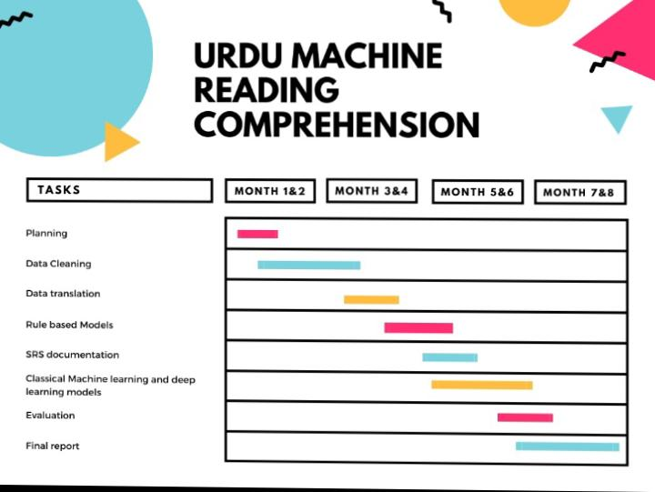

Analysis and Modeling of Requirements


Nonfunctional Requirements

Target Performance
As we will be using google for the translation of our data set and its translation accuracy is above 90%. That is why we will be using it as for the conversion of out datasets into Urdu language. After that we will be implementation two methods rule based and machine learning based in order to answer the questions of the article provided by the user.
The system should be very user friendly and self-explanatory.

Other Requirements
- RAM: 2 GB or more
- Windows 7 – Windows 10
- 100 Gb hard or more

Initial Results
<Provide initial results obtained so far>

Revised Project Plan


References
- Trung, L. H. (2019). https://euroasia-science.ru/pdf-arxiv/the-controllability-function-of-polynomial-for-descriptor-systems-23-31/. EurasianUnionScientists, 4(65). https://doi.org/10.31618/esu.2413 9335.2019.4.65.27

- CiteSeerX — query based Arabic text summarization 1. (n.d.). Retrieved December 6, 2021, from https://citeseerx.ist.psu.edu/viewdoc/summary?doi=10.1.1.308.4480.

- Zhao, M., Yan, S., Liu, B., Zhong, X., Hao, Q., Chen, H., Niu, D., Long, B., & Guo, W. (2020, October 28). QBSUM: A large-scale query-based document summarization dataset from real-world applications. Computer Speech & Language. Retrieved December 6, 2021, from https://www.sciencedirect.com/science/article/abs/pii/S0885230820300991.

- Kumar, Y., Kaur, K., & Kaur, S. (2021, February 12). Study of automatic text summarization approaches in different languages. Artificial Intelligence Review. Retrieved December 6, 2021, from https://link.springer.com/article/10.1007/s10462-021-09964-4.

- Nawaz, A., Bakhtyar, M., Baber, J., Ullah, I., Noor, W., & Basit, A. (2020, September 25). Extractive text summarization models for Urdu language. Information Processing & Management. Retrieved December 6, 2021, from https://www.sciencedirect.com/science/article/abs/pii/S0306457320308785.

- Nguyen, T., Rosenberg, M., Song, X., Gao, J., Tiwary, S., Majumder, R., & Deng, L. (2016, January). MS MARCO: A human generated machine reading comprehension dataset. In CoCo@ NIPS.

- Sun, K., Yu, D., Yu, D., & Cardie, C. (2018). Improving machine reading comprehension with general reading strategies. arXiv preprint arXiv:1810.13441.

- Baradaran, R., Ghiasi, R., & Amirkhani, H. (2020). A survey on machine reading comprehension systems. Natural Language Engineering, 1-50.

- Zhang, Z., Yang, J., & Zhao, H. (2020). Retrospective reader for machine reading comprehension. arXiv preprint arXiv:2001.09694, 1, 1-9.

- Liu, S., Zhang, X., Zhang, S., Wang, H., & Zhang, W. (2019). Neural machine reading comprehension: Methods and trends. Applied Sciences, 9(18), 3698.

- Zhang, Z., Zhao, H., & Wang, R. (2020). Machine reading comprehension: The role of contextualized language models and beyond. arXiv preprint arXiv:2005.06249.

- Guo, S., Guan, Y., Tan, H., Li, R., & Li, X. (2021). Frame-based neural network for machine reading comprehension. Knowledge-Based Systems, 219, 106889.

- Ahmed, S. (2021). UQuAD1. 0: Development of an Urdu Question Answering Training Data for Machine Reading Comprehension.

- Gupta, V., Joshi, N., & Mathur, I. (2014). Evaluation of English-to-Urdu Machine Translation. In Intelligent Computing, Networking, and Informatics (pp. 351-358). Springer, New Delhi.

Appendix A: Glossary
<Define all the terms necessary to properly interpret the SRS, including acronyms and abbreviations. You may wish to build a separate glossary that spans multiple projects or the entire organization, and just include terms specific to a single project in each SRS.>
Appendix B: IV & V Report
(Independent verification & validation)
IV & V Resource

Name Signature

S# | Defect Description | Origin Stage | Status | Fix Time
 |  |  |  | Hours | Minutes
1
2
3
…
Table 3: List of non-trivial defects

